PROJECT DEVELOPMENT SPRINT - 2

|  |  |
| --- | --- |
| Date | 16 November 2022 |
| Team ID | PNT2022TMID26870 |
| Project Name | Project – Smart Farmer - IoT Enabled Smart Farming Application |

Project Build

:

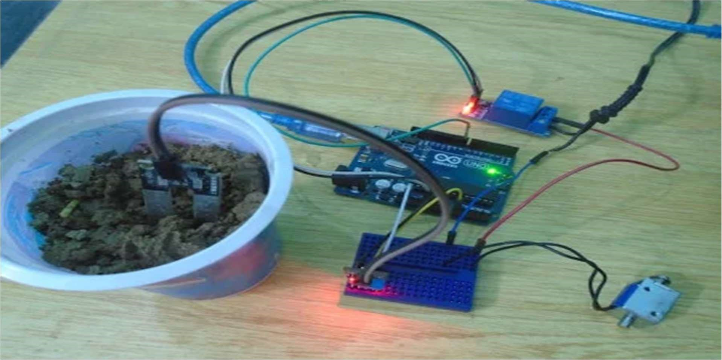

• Project Sensors 80% Completed, • Few Sensors Yet To Add.

IBM IOT Watson Platform :

